PROJECT REPORT

EMPLOYEE REQUESTS INSTALLATION OF LICENSED SOFTWARE THROUGH THE SERVICE CATALOG

ServiceNow Service Catalog and Workflow Automation

Student ID: 23NU1A0511
Submitted by: Burada Laxmi Sai Priyanka

Table of Contents

INTRODUCTION
  - Project Overview
  - Purpose

IDEATION PHASE
  - Problem Statement
  - Empathy Map Canvas
  - Brainstorming & Idea Prioritization

REQUIREMENT ANALYSIS
  - Customer Journey Map
  - Solution Requirement
  - Data Flow Diagram
  - Technology Stack

PROJECT DESIGN
  - Problem Solution Fit
  - Proposed Solution
  - Solution Architecture

PROJECT PLANNING & SCHEDULING
  - Project Planning

FUNCTIONAL AND PERFORMANCE TESTING
  - Functional Testing
  - User Acceptance Testing (UAT)

RESULTS
  - Output Screenshots
  - Work Item Status Validation
- ADVANTAGES & DISADVANTAGES
- CONCLUSION
- FUTURE SCOPE
- APPENDIX
Source Code Dataset Link
GitHub & Project Demo Link

INTRODUCTION

Project Overview
The Employee Requests Installation of Licensed Software through the Service Catalog project is a ServiceNow-based solution that manages employee requests for installing licensed software. It gives employees a structured way to submit a software installation request through the ServiceNow Service Catalog, obtain approval, and initiate fulfillment through a catalog task.
The project focuses on request submission, collecting the required information through catalog variables, approval workflow automation, and fulfillment task creation. An employee opens the Software Installation Request catalog item and enters the Software Name, Version Required, License Justification, and Urgency. After submission, ServiceNow creates the Request (REQ) and Requested Item (RITM) records, and the Software Request Workflow sends the request for manager approval. Once the request is approved, a catalog task named Software Fulfillment Task is created and assigned to the Software assignment group.
The project manages the request process within ServiceNow; it does not automatically install software on an employee’s computer. The configuration was packaged in an Update Set and moved to a target instance.

High-Level Flow
Employee → Service Catalog → REQ/RITM → Manager Approval → Catalog Task → Software Support Team → Task Processing → Status Tracking
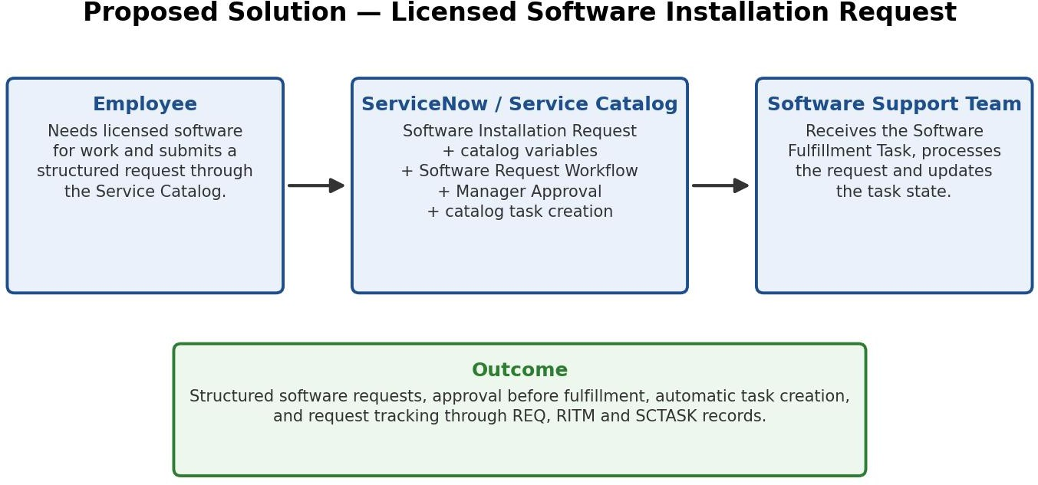

Figure 1: High-level workflow of the Licensed Software Installation Request process.

Purpose
The purpose of this project is to provide a centralized and structured process for managing employee requests for licensed software installation. The system aims to:
    - Provide a Service Catalog item for licensed software installation requests.
    - Collect relevant request information through catalog variables.
    - Route every request through an approval workflow.
    - Create a fulfillment task for the Software team after approval.

    - Maintain request and task records (REQ, RITM, SCTASK) in ServiceNow for tracking.
    - Package the configuration in an Update Set so it can be moved between ServiceNow instances.
    - Provide a foundation for future enhancements such as license availability validation and SLA tracking.

IDEATION PHASE

Problem Statement
Employees may need different licensed software applications to perform their work. Without a structured request process, software installation requests may be submitted inconsistently, approvals may be difficult to track, and the IT team may lack a clear record of the work required.
This lack of structure results in:
    - Inconsistent and incomplete software requests.
    - Approvals that are difficult to track.
    - No clear record of the work required from the IT team.

Problem Statement Canvas

Parameter | Description
User | Employees requesting licensed software
Problem | Software requests are submitted inconsistently, approvals are hard to track, and the IT team lacks a clear record of the work required
Need | A simple and structured request process with approval and a fulfillment task
Impact | Untracked approvals, unclear fulfillment work and delays in software installation
How Might We? | How might we provide a structured way for employees to request licensed software, obtain approval, and give the IT team a clear fulfillment task?

Empathy Map Canvas
Empathy map for the Employee / End User:

Dimension | Employee Perspective
Says | I need a simple way to request the software I require.
Thinks | I want a clear form with relevant software and request options.
Does | Opens the portal, selects the Software Installation Request, and submits the details.
Feels | Wants fast, reliable and transparent software support.
Pain Points | Unclear approval status and delayed fulfillment.
Needs / Goals | Simple submission, clear tracking, timely approval and a fulfilled request.

Brainstorming & Idea Prioritization

Brainstorming Overview
The original brainstorming session produced 12 ideas. Related ideas were consolidated into nine ideas to reduce overlap. The nine consolidated ideas, their priority, and their status are listed below.

No. | Idea | Priority | Status
1 | Service Catalog item for licensed software requests | High | Implemented
2 | Catalog variables for structured request details | High | Implemented
3 | Approval workflow | High | Implemented
4 | Fulfillment task creation and assignment | High | Implemented
5 | Request status tracking | High | Supported through standard records
6 | Catalog UI Policies | High | Considered, not implemented
7 | Custom licensed software table | High | Considered, not implemented
8 | Email notifications | Medium | Considered, not implemented
9 | Reports and dashboards | Medium | Considered, not implemented

Idea Grouping

Functional Area | Ideas
Request Submission and Information Collection | Service Catalog item; Catalog variables; Catalog UI Policies (possible enhancement)
Approval Processing | Approval workflow
Fulfillment Task Management | Fulfillment task creation and assignment
Tracking and Communication | Request tracking through standard records; Email notifications (possible enhancement)
Data Management, Reporting and Analytics | Custom licensed software table; Reports and dashboards

Idea Prioritization
The nine consolidated ideas carry the following priority distribution: 7 High priority ideas and 2 Medium priority ideas. This is a summary of the consolidated ideas and is not an Impact–Feasibility matrix.

Final Selected Ideas
Based on priority and feasibility, the following ideas were selected for implementation:
- Service Catalog item for software installation requests.
- Catalog variables for collecting request details.
- Approval workflow.

- Fulfillment task creation and assignment.
- Request status tracking through standard ServiceNow records.
Decision: An employee submits a software request, the request passes through the configured approval workflow, and a fulfillment task is created for the Software team. Catalog UI Policies, a custom licensed software table, email notifications, and reports and dashboards were considered but not implemented. Automatic license availability checking and inventory validation, SLA tracking, additional approval routing, and integration with a software deployment tool are future enhancements.

REQUIREMENT ANALYSIS

Customer Journey Map
The employee journey begins when the user accesses the Service Portal and ends when the software request has been fulfilled by the Software team.

Stage | Employee Action | System Response
Access | Opens the Service Portal | Portal displays the Service Catalog
Discover | Finds the Software Installation Request in the Software category | Catalog item is displayed
Submit | Enters software name, version, justification and urgency | Catalog variables capture the information
Process | Submits the request | REQ and RITM records are created
Approval | Waits for the approval decision | Software Request Workflow sends the RITM for Manager Approval
Fulfillment | Request is processed after approval | Software Fulfillment Task is created and assigned to the Software group
Completion | Tracks the request status | Request, RITM and catalog task records show progress; the team updates the task state

Solution Requirement

Functional Requirements

ID | Requirement
FR-01 | Employees shall be able to access the Service Catalog and open the Software Installation Request item.
FR-02 | The system shall capture Software Name and Version Required.
FR-03 | The system shall capture License Justification and Urgency.
FR-04 | The system shall create REQ and RITM records after submission.
FR-05 | The request shall be routed for approval.
FR-06 | A catalog task shall be created after approval.
FR-07 | The task shall be assigned to the Software assignment group.
FR-08 | The Software team shall be able to process the task and update its state.
FR-09 | The request shall remain traceable through REQ, RITM and SCTASK records.

Non-Functional Requirements

ID | Requirement
NFR-01 | The system should provide a simple and structured request form.
NFR-02 | The workflow should process requests consistently.
NFR-03 | The configuration should be maintainable and deployable through an Update Set.

Software Requirements
    - ServiceNow instance with Service Catalog, Service Portal and Workflow Studio available
    - Modern web browser (Chrome, Edge, Firefox)

Hardware Requirements
    - Standard desktop/laptop computer
    - Stable internet connection

Data Flow Diagram
Employee Input → Catalog Variables → Service Catalog → REQ/RITM → Manager Approval → Catalog Task → Software Support Team → Task Processing
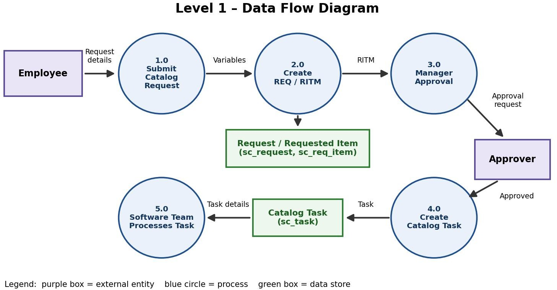
Figure 3: Logical data flow of the Licensed Software Installation Request process.

Technology Stack

Layer | Technologies Used
Presentation / UI Layer | ServiceNow Service Portal, Service Catalog
Application / Business Logic Layer | Catalog Item, Catalog Variables, Workflow Studio (Software Request Workflow), Approval functionality
Data Layer | Request (sc_request), Requested Item (sc_req_item), Catalog Task (sc_task)
Assignment Layer | Assignment Group: Software
Deployment Layer | Update Set: Licensed Software Installation - Capstone
Cloud / Infrastructure Layer | ServiceNow Cloud Platform

PROJECT DESIGN

Problem Solution Fit
The project addresses the problem of inconsistent and hard-to-track software installation requests. The proposed ServiceNow-based solution lets an employee submit a request through a dedicated Service Catalog item, captures the information in catalog variables, routes the request through an approval workflow, and creates a fulfillment task for the Software team.
The solution gives the IT team a clear record of the work required and keeps the approval and fulfillment steps traceable through REQ, RITM and SCTASK records.

Proposed Solution
The proposed solution is a Service Catalog item named Software Installation Request in the existing Software category. Employees submit requests through this catalog item. The Software Request Workflow, configured on the Requested Item table (sc_req_item), sends the request for Manager Approval and, after approval, creates a catalog task assigned to the Software group.

Catalog Variables

Variable | Form Question | Type | Purpose
Software Name | What software do you need? | Single Line Text | Captures the name of the software requested by the employee
Version Required | Specify version (if required) | Single Line Text | Records the required software version
License Justification | Why do you need this software? | Multi Line Text | Captures the reason the employee needs the software
Urgency | Select urgency level. | Select Box | Records the urgency as Normal, High, or Critical

Workflow Configuration
The workflow is named Software Request Workflow and is configured in Workflow Studio on the Requested Item table (sc_req_item). It is triggered by the Service Catalog request and runs in the following sequence:
- Ask For Approval on Requested Item (approval reason: Manager Approval).
- If Approval Approved – the flow continues only when the approved condition is met.
- Create Catalog Task – a catalog task with the short description Software Fulfillment Task is created and assigned to the Software group.

S.No. | Parameter | Description
1 | Problem Statement | Software installation requests may be submitted inconsistently, approvals may be hard to track, and the IT team may lack a clear record of the work required.

S.No. | Parameter | Description
2 | Idea / Solution Description | A ServiceNow Service Catalog item with four catalog variables, a manager approval workflow, and an automatically created fulfillment task assigned to the Software team.
3 | Novelty / Uniqueness | Combines request submission, approval and fulfillment task creation in one ServiceNow process, with the configuration packaged in an Update Set.
4 | Customer Satisfaction | Employees use one structured form and the request stays traceable through REQ, RITM and SCTASK records.
5 | Business Model | Academic capstone project; it does not directly generate revenue.
6 | Scalability | Can be extended with license availability validation, SLA tracking, additional approval routing and software deployment tool integration.

Solution Architecture
The employee accesses the Software Installation Request through the Service Portal and Service Catalog. Catalog variables capture the request details, and ServiceNow creates the REQ and RITM records. The Software Request Workflow sends the RITM for Manager Approval and, once approved, creates a catalog task (SCTASK) that is assigned to the Software group. The configuration is packaged in the Licensed Software Installation - Capstone Update Set.
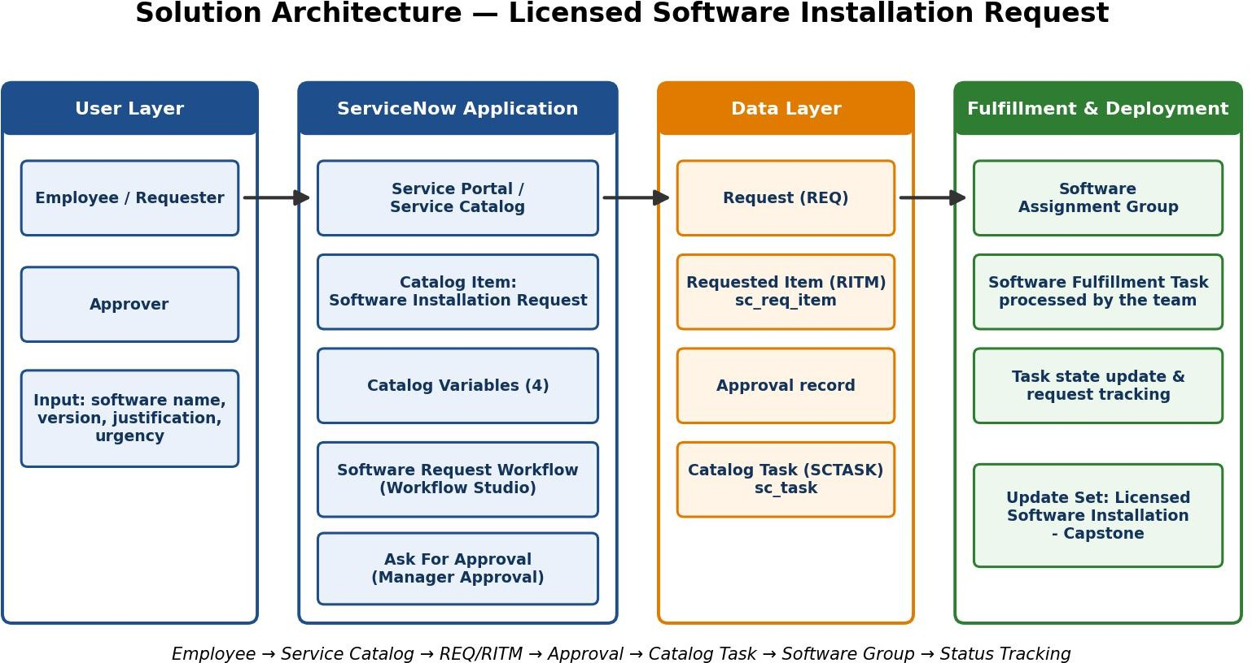
Figure 4: Solution architecture of the Licensed Software Installation Request process.

PROJECT PLANNING & SCHEDULING

Project Planning
Stakeholders: Employee / Requester, Approver, Software Support Team, ServiceNow Administrator.

Execution Phases (Completed)

Phase | Title | Key Activities | Status
1 | Requirement Analysis & Planning | Identify the need, stakeholders, ServiceNow components, request process and functional requirements | Completed
2 | Service Catalog & Form Configuration | Create the Software Installation Request catalog item and configure the catalog variables | Completed
3 | Workflow Automation & Approval | Configure the Software Request Workflow, Ask For Approval and catalog task creation | Completed
4 | Testing & Validation | Test request submission, REQ/RITM generation, approval, catalog task creation and flow execution | Completed
5 | Deployment, Documentation & Final Presentation | Complete, export, import, preview and commit the Update Set; validate the target instance; document the project | Completed

Execution Roadmap (Milestones)
Catalog Item Setup → Catalog Variables → Workflow and Manager Approval → Catalog Task Creation → Testing & Validation → Update Set Deployment → Target Instance Validation

FUNCTIONAL AND PERFORMANCE TESTING

Functional Testing
Testing was performed by submitting a software request and reviewing the resulting request records, approval, flow execution and fulfillment task.

Test ID | Scenario | Expected Result | Status
TC-01 | Open the Software Installation Request catalog item | Catalog item opens in the Service Portal | Pass
TC-02 | Enter request details | Four catalog variables are available and accept input | Pass
TC-03 | Submit request | REQ and RITM are created (REQ0010006 / RITM0010006) | Pass
TC-04 | Approval routing | Request is sent for Manager Approval | Pass
TC-05 | Approval decision | Approval reaches Approved state (RITM0010002) | Pass
TC-06 | Catalog task creation | Software Fulfillment Task is created (SCTASK0010009) | Pass
TC-07 | Assignment | Task is assigned to the Software group | Pass
TC-08 | Flow execution | Software Request Workflow completes successfully | Pass
TC-09 | Update Set deployment | Update Set is exported, imported, previewed and committed | Pass
TC-10 | Target instance validation | Catalog item and flow execution verified in target instance | Pass
Observation: all functional test scenarios within the implemented scope passed.

User Acceptance Testing (UAT)

UAT ID | Scenario | Acceptance Criteria | Result
UAT-01 | Open the catalog item | Request form opens | Accepted
UAT-02 | Enter software details | Software name, version, justification and urgency can be entered | Accepted
UAT-03 | Submit request | REQ and RITM are created | Accepted
UAT-04 | Approval | Approval record reaches Approved state | Accepted
UAT-05 | Task creation | Catalog task is created after approval | Accepted
UAT-06 | Task assignment | Task is assigned to the Software group | Accepted
UAT-07 | Deployment | Configuration works in the target instance | Accepted

UAT Conclusion
The tested request workflow satisfies the documented acceptance criteria for the implemented scope: request submission, approval, fulfillment task creation and deployment through an Update Set.

RESULTS
The following figures present the implementation evidence captured from the ServiceNow project. They cover catalog configuration, submitted variables, workflow automation, approval, fulfillment task creation, and Update Set deployment evidence.

Output Screenshots

Sample Test Data

Variable | Value Submitted
Software Name | Microsoft Office 365
Version Required | 2021
License Justification | Required for daily work
Urgency | High
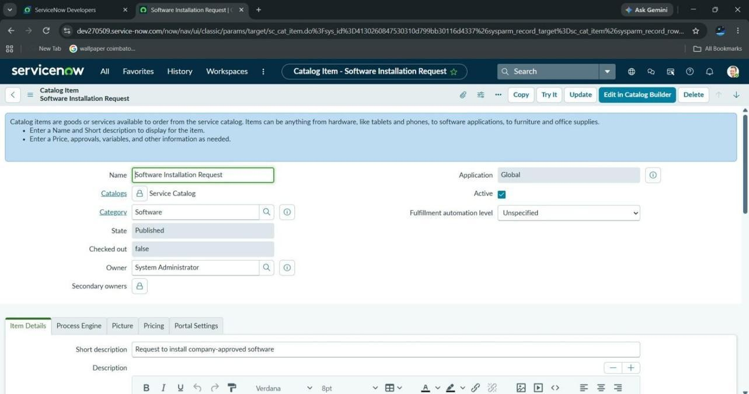
Figure 7.1: Software Installation Request – Catalog Item Configuration.

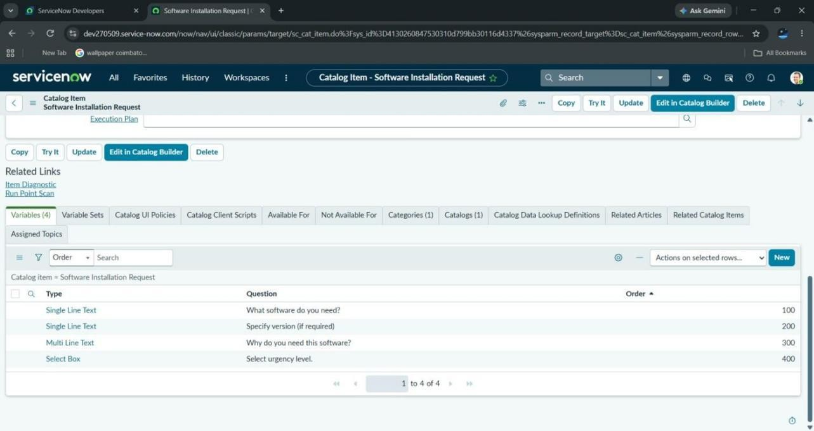
Figure 7.2: Software Installation Request – Configured Catalog Variables.
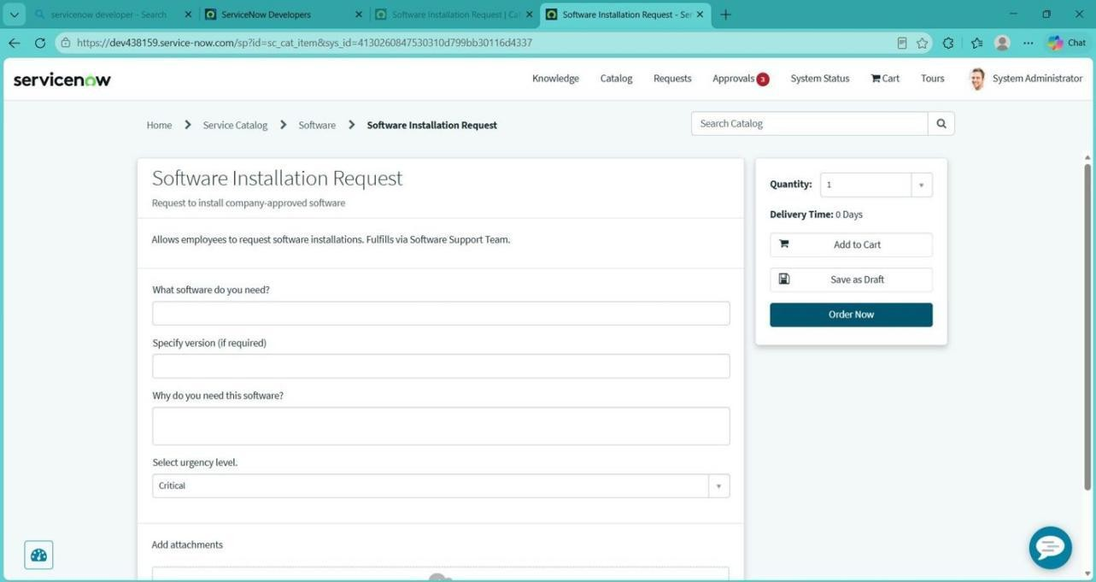
Figure 7.3: Software Installation Request – Service Portal Request Form.

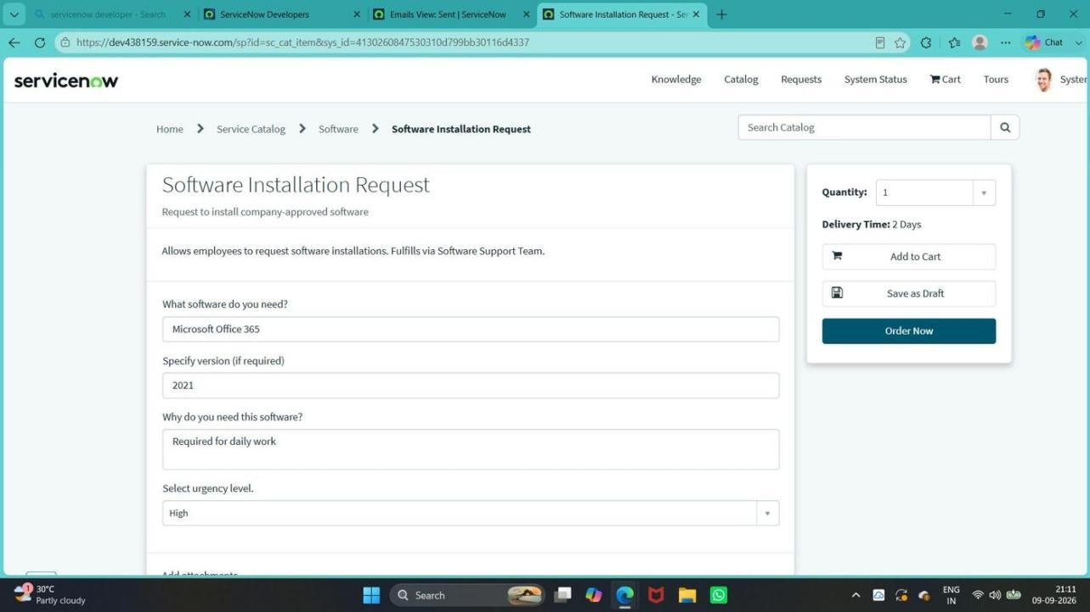
Figure 7.4: Software Installation Request – Filled Service Portal Request Form.
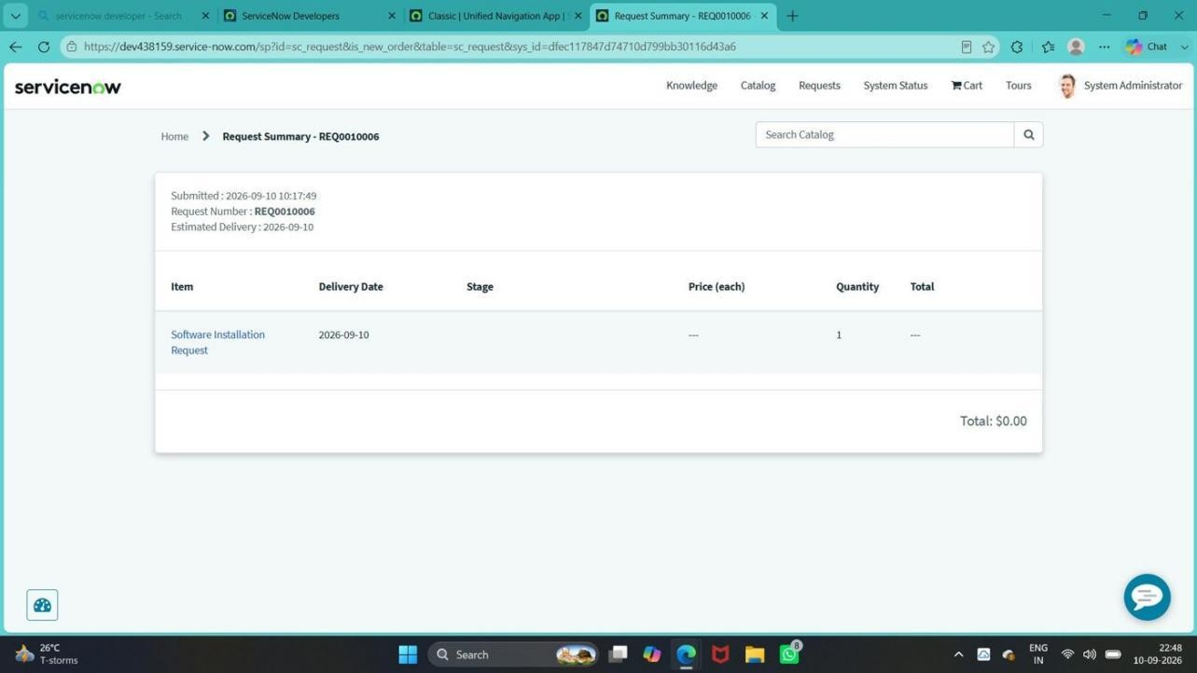
Figure 7.5: Software Installation Request – Generated Request (REQ0010006) Summary.

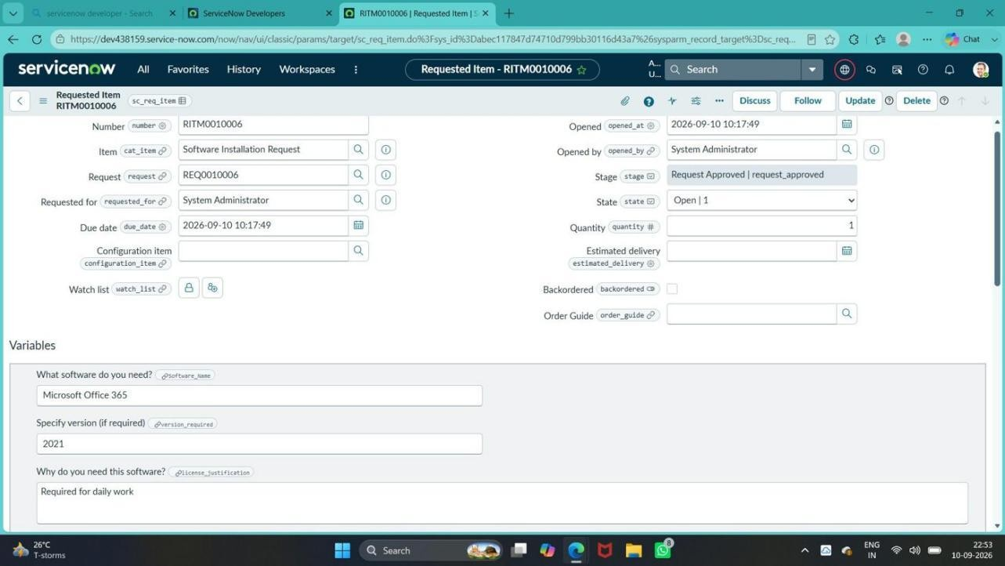
Figure 7.6: Software Installation Request – Generated Requested Item (RITM0010006).
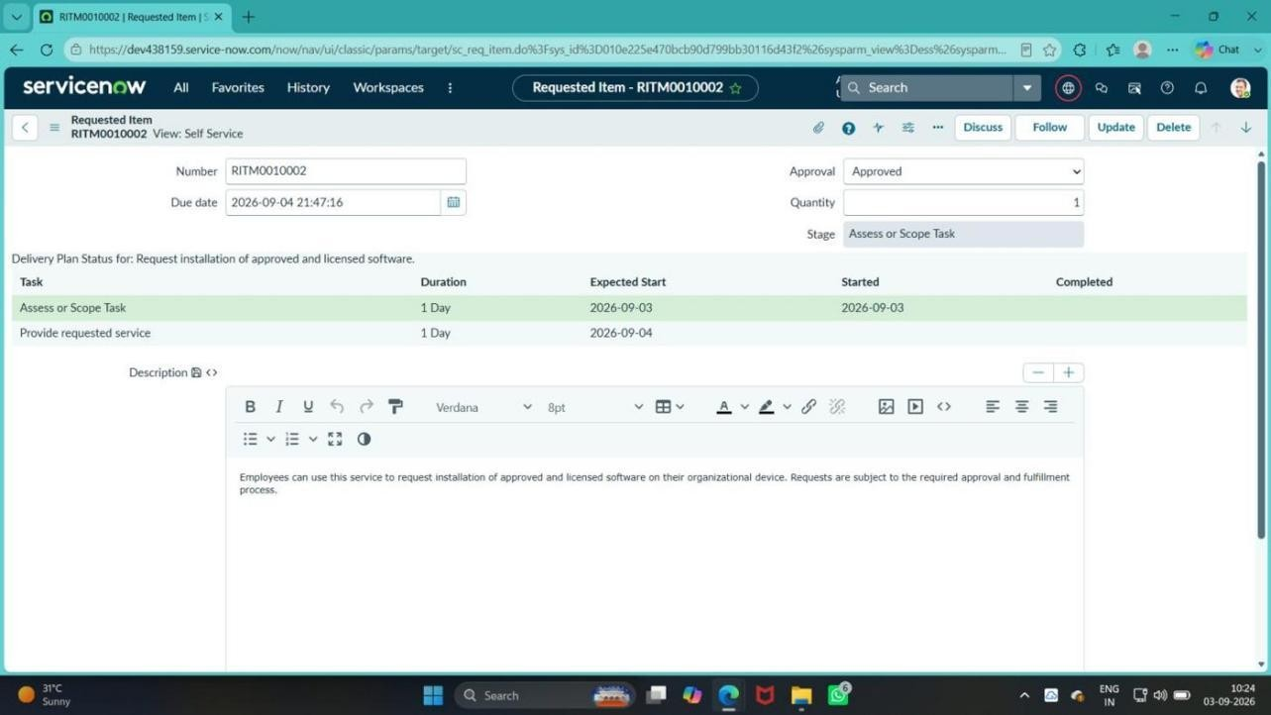
Figure 7.7: Requested Item RITM0010002 with Approval: Approved.

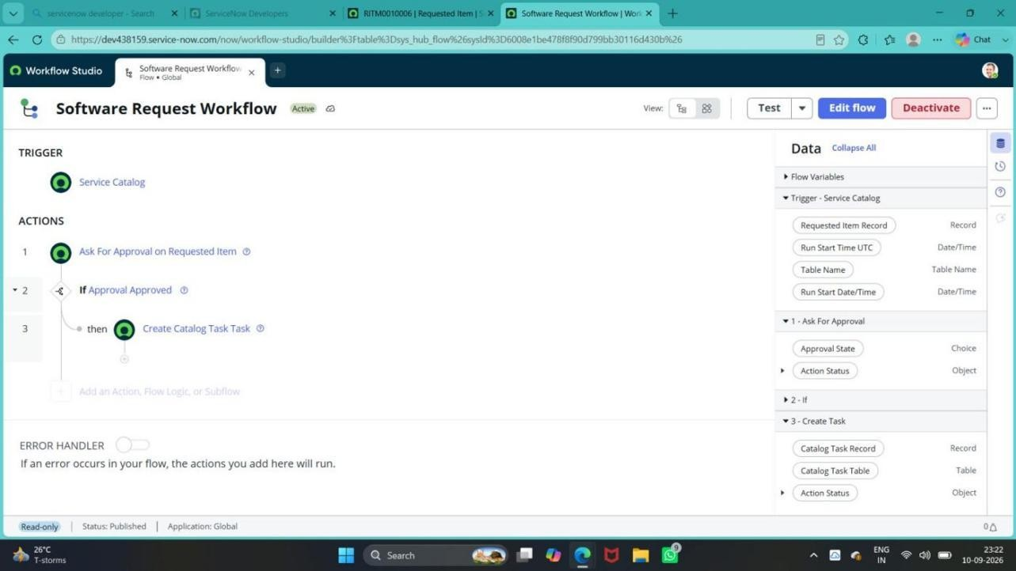
Figure 7.8: Software Request Workflow – Workflow Automation Configuration.
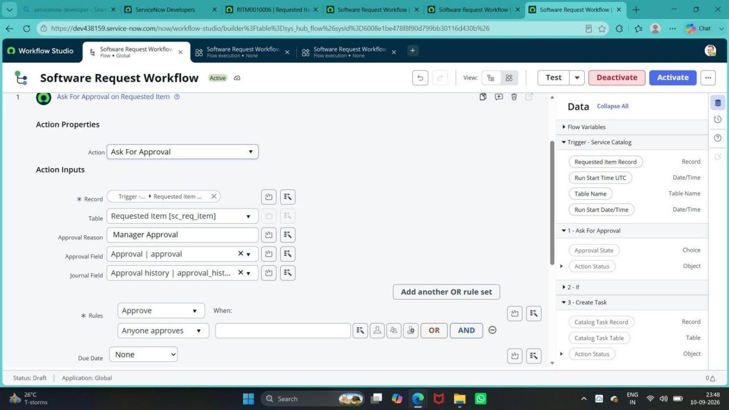
Figure 7.9: Software Request Workflow – Ask For Approval Configuration.

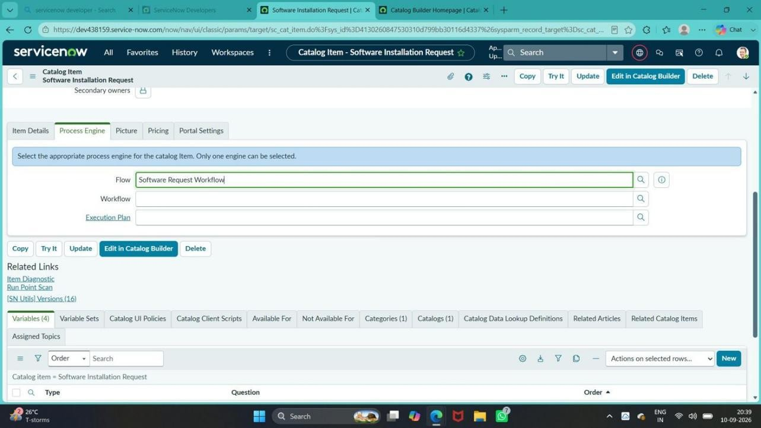
Figure 7.10: Software Installation Request – Process Engine Configuration.
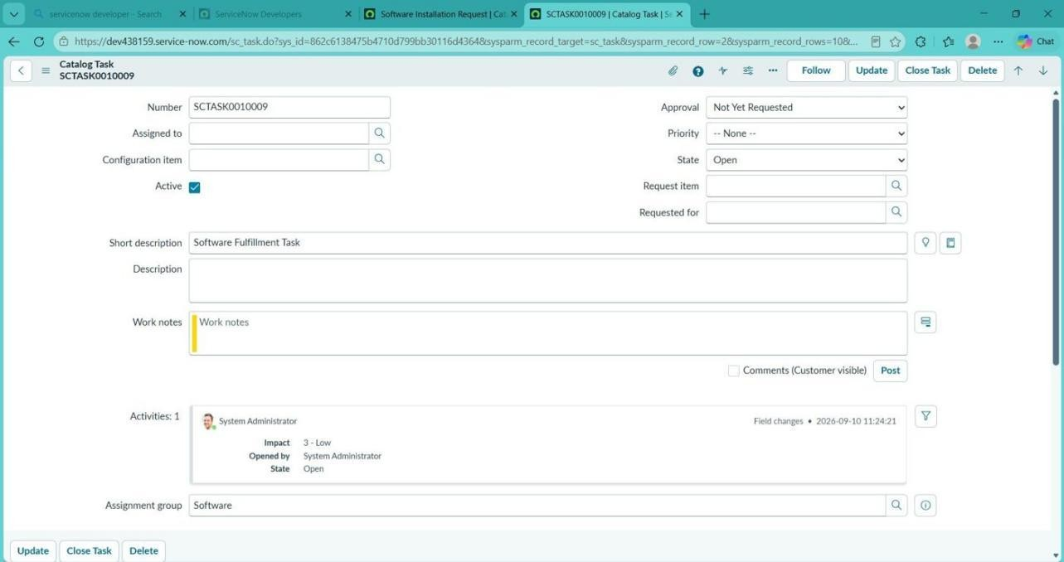
Figure 7.11: Software Fulfillment Task – Catalog Task SCTASK0010009 assigned to Software.

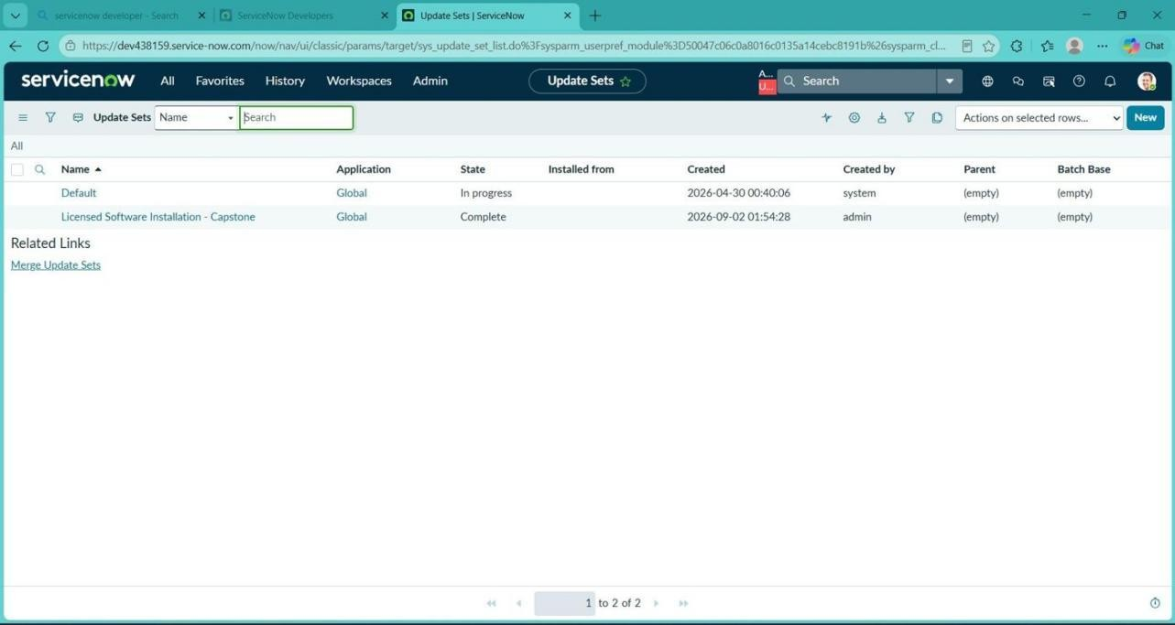
Figure 7.12: Licensed Software Installation - Capstone – Update Set Completed.
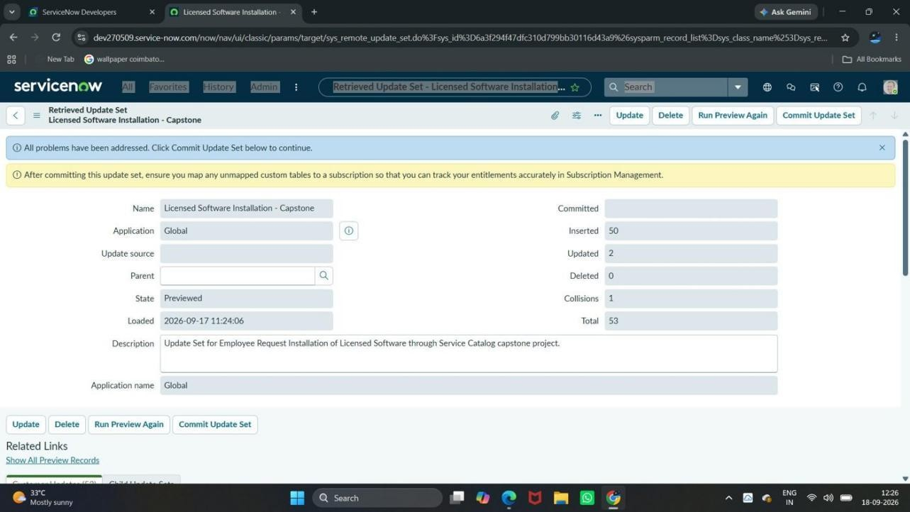
Figure 7.13: Licensed Software Installation - Capstone – Update Set Preview Resolved.

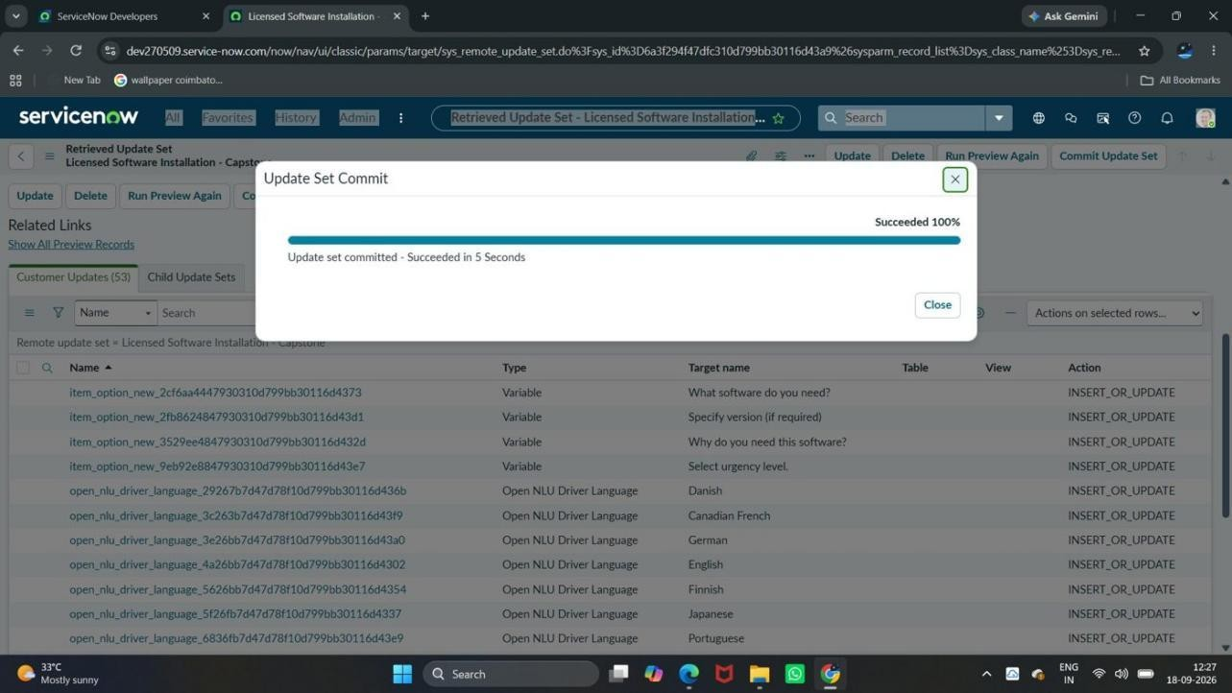
Figure 7.14: Licensed Software Installation - Capstone – Update Set Committed.
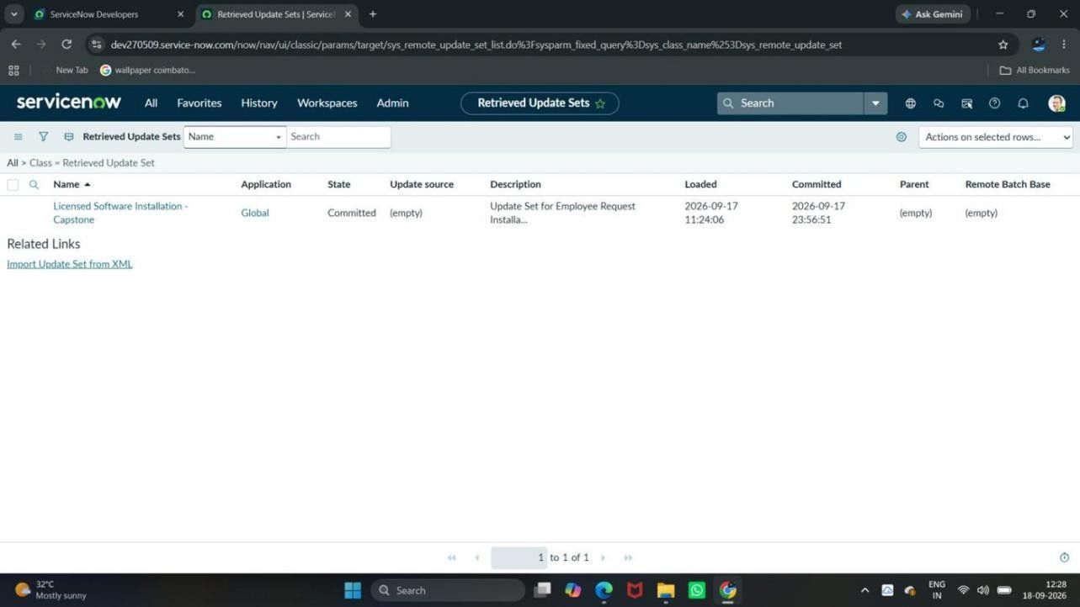
Figure 7.15: Retrieved Update Set – State: Committed.

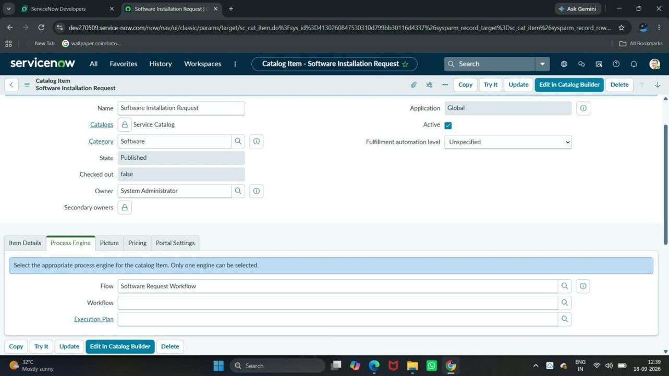
Figure 7.16: Target Instance – Software Installation Request Catalog Item.
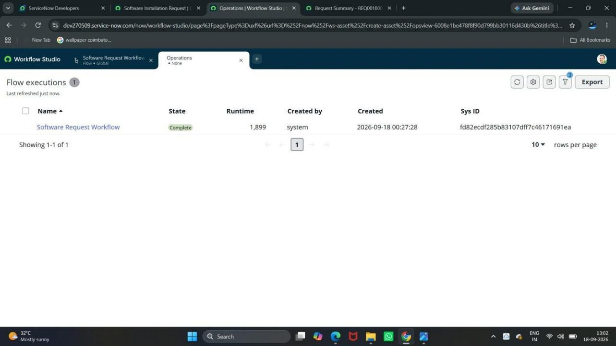
Figure 7.17: Target Instance – Software Request Workflow Flow Executions (Complete).

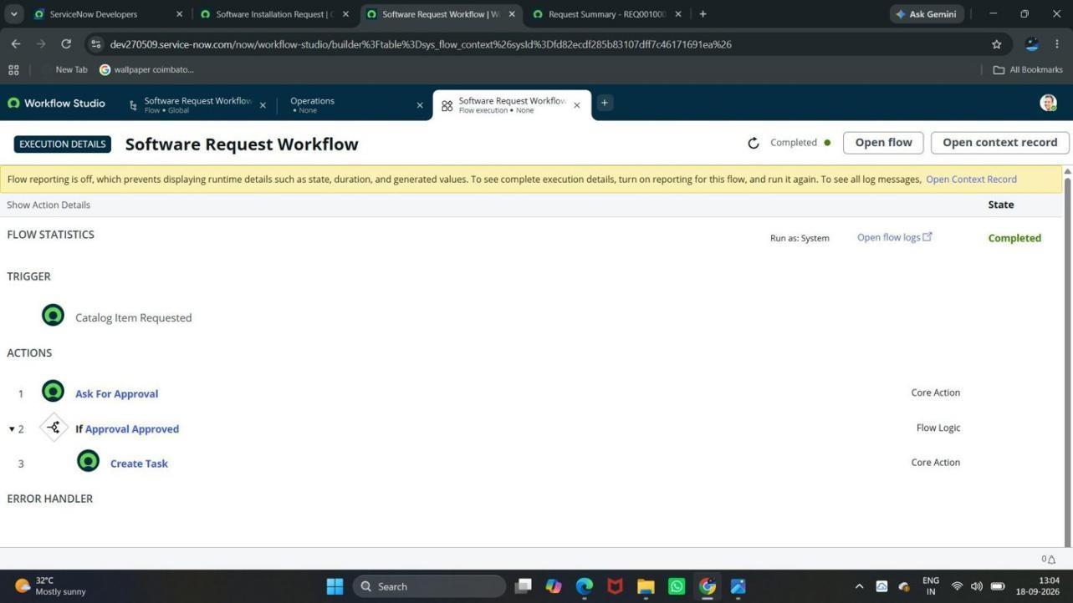
Figure 7.18: Target Instance – Software Request Workflow Execution Details (Completed).

Work Item Status Validation

Component | Status | Validation
Software Installation Request catalog item | Completed | Catalog item created in the Software category and accessible
Catalog Variables | Completed | Four variables configured and shown on the request form
Software Request Workflow | Completed | Workflow configured on sc_req_item and linked through the catalog item process engine
Manager Approval | Completed | Approval record reached the Approved state
Software Fulfillment Task | Completed | Catalog task created after approval
Software Assignment Group | Completed | Task assigned to the Software group
Update Set | Completed | Exported, imported, previewed, committed and validated in the target instance

Testing Evidence Records

Record | Number
Request | REQ0010002
Requested Item | RITM0010002
Catalog Task | SCTASK0010009
Approval | Approved

ADVANTAGES & DISADVANTAGES

Advantages
- Provides a single, centralized Service Catalog item for licensed software requests.
- Collects the software name, version, justification and urgency in a structured form.
- Routes every request through a manager approval before fulfillment.
- Automatically creates a fulfillment task after approval.
- Assigns the task to the Software team, giving the IT team a clear record of the work.
- Keeps the request traceable through REQ, RITM and SCTASK records.
- Uses standard ServiceNow features with no custom development.
- Configuration is packaged in an Update Set for controlled movement between instances.

Disadvantages
- The solution manages the request process only; it does not automatically install software on the employee’s computer.
- License availability checking and software inventory validation are not implemented.
- SLA tracking, email notifications, and reports and dashboards are not implemented.
- Catalog UI Policies and a custom licensed software table were considered but not implemented.
- Depends on correct ServiceNow configuration, including the approver and assignment group.

CONCLUSION
The Employee Requests Installation of Licensed Software through the Service Catalog project uses ServiceNow to organize software installation requests. It collects request information through catalog variables, uses a workflow on the Requested Item table for approval processing, and creates a fulfillment task assigned to the Software group.
The project demonstrates the use of Service Catalog configuration, workflow automation, approval processing, task creation, and Update Sets. The current scope focuses on request management and fulfillment coordination, with license inventory validation, SLA tracking, additional routing, reporting, and software deployment integration remaining potential future enhancements.

FUTURE SCOPE
- Automatic license availability checking and inventory validation.
- SLA tracking for request processing.
- Additional approval routing.
- Integration with a software deployment tool.
- Catalog UI Policies for dynamic form behavior.
- A custom licensed software table.
- Email notifications at key stages of the request.

- Reports and dashboards for request visibility.

APPENDIX

Source Code
Not applicable – the solution was implemented through ServiceNow configuration (catalog item, catalog variables, Software Request Workflow and Update Set). No custom source code was written.

Dataset Link
Not applicable – the project uses standard ServiceNow records (Request, Requested Item and Catalog Task) created within the instance, rather than an external dataset.

Update Set Details

Item | Detail
Update Set Name | Licensed Software Installation - Capstone
Customer Updates | 53 (Inserted 50, Updated 2)
Final State | Committed in the target instance

GitHub & Project Demo Link
GitHub Repository: https://github.com/laxmisaipriyanka-2005/licensed-software-installation-servicenow
Project Demo Video: https://1drv.ms/v/c/c5f2adc4823346b4/IQCS7GG5A5IeSL20e1eX_e4SAXxKNyQWN8PHInsq9S0zb2A?e=W2WO7X

